

Ice cream, you scream!

Design brief for Year 3 and 4 Design and Technologies

**Background:** You have been learning about data and how to present data in different ways using a range of simple software as well as collecting and collating it to present.

**Challenge:** Your challenge is to invent a new ice cream flavour for the school’s ice creamery that has never been thought of before! You will need to conduct surveys to find out which ice cream flavour you are going to invent to sell.

**Criteria:**

Your ice cream must:

* Be created during the allocated class time and during lunch breaks
* Be delicious for all children

**Materials:**

* Computer/Laptop/iPad with internet access

**Teacher Notes**

|  |  |  |  |
| --- | --- | --- | --- |
| **Objective**  Students will learn and understand that humans create things to serve a purpose, desire or want as well as collect, access, present and represent data in a number of different ways by using hands on approaches and simple software. It will be seen that students understand that this information is collected in ethical ways and is scaffolded by the appropriate worksheets provided to them for the duration of this task. | | | |
| **Australian Curriculum Content Descriptors** | | | |
| *Digital Technologies*   * Collect, access and present different types of [data](http://www.australiancurriculum.edu.au/glossary/popup?a=T&t=data) using simple software to create information and solve problems [(ACTDIP009)](http://www.australiancurriculum.edu.au/curriculum/contentdescription/ACTDIP009) * Recognise different types of [data](http://www.australiancurriculum.edu.au/glossary/popup?a=T&t=data) and explore how the same [data](http://www.australiancurriculum.edu.au/glossary/popup?a=T&t=data) can be represented in different ways [(ACTDIK008)](http://www.australiancurriculum.edu.au/curriculum/contentdescription/ACTDIK008)   *Mathematics*   * Select and trial methods for [data](http://www.australiancurriculum.edu.au/glossary/popup?a=M&t=Data) collection, including survey questions and recording sheets[(ACMSP095)](http://www.australiancurriculum.edu.au/curriculum/contentdescription/ACMSP095) * Construct suitable [data](http://www.australiancurriculum.edu.au/glossary/popup?a=M&t=Data) displays, with and without the use of digital technologies, from given or collected [data](http://www.australiancurriculum.edu.au/glossary/popup?a=M&t=Data). Include tables, column graphs and [picture graphs](http://www.australiancurriculum.edu.au/glossary/popup?a=M&t=Picture+graphs) where one picture can represent many [data](http://www.australiancurriculum.edu.au/glossary/popup?a=M&t=Data) values [(ACMSP096)](http://www.australiancurriculum.edu.au/curriculum/contentdescription/ACMSP096) | | | |
| **General Capabilities** | | | |
| **Literacy** | **Comprehending texts through listening, reading and viewing**   * Comprehend texts * Navigate, read and view learning area texts * Interpret and analyse learning area texts   **Word Knowledge**   * Understand learning area vocabulary   **Composing texts through speaking, writing and creating**   * Compose texts * Compose spoken, written, visual and multimodal learning area texts   **Text knowledge**   * Use knowledge of text structures   **Visual Knowledge**   * Understand how visual elements create meaning | **Numeracy** | **Interpreting statistical information**   * Interpret data displays |
| **ICT Capability** | **Investigating with ICT**   * Define and plan information searches   **Creating with ICT**   * Generate ideas, plans and processes * Generate solutions to challenges and learning area tasks   **Managing and operating ICT**   * Understand ICT systems | **Critical and Creative Thinking** | **Inquiring – identifying, exploring and organising information and ideas**   * Pose questions * Identify and clarify information and ideas * Organise and process information   **Generating ideas, possibilities and actions**   * Consider alternatives * Seek solutions and put ideas into action   **Reflecting on thinking and processes**   * Transfer knowledge into new contexts |

**Materials:** List provided on Cover Page

**Safety Issues:** Discussion of safe use of scissors, glue, pointy objects

**Class Management:** Individual task, inside and outside supervision provided,

**Time Management:** (Lessons are 40 minutes long)

Lesson 1 – Introduce design brief and show students the “job advertisement” on the interactive whiteboard as well as the printed copy that will be able to be seen in the classroom for the duration of the task. Start discussion on task and 5 flavours that students wish to invent, students’ form a hypothesis about which ice cream flavour they think will be the most popular choice and justify their reasoning.

Lesson 2 – Discuss previous mathematics lessons in regards to qualitative and quantitative data and ensure students recognise that data can be represented in different ways. Reiterate what needs to be included in a number of different representations of data and their layout including; column graphs, bar graphs, pie graphs, etc. Discuss that students will use their survey sheet to collate their data and upon completion they will put this data into tally form.

Lesson 3 –Brainstorm questions for a survey in which students will be required to interview peers from another class and discuss how data can be collected to see what flavour boys prefer and what flavour girls prefer.

Lesson 4 – Students put their data into tally form and then transfer it into a column graph created in Microsoft Excel.

Lesson 5 – Students analyse their data and come to a conclusion about which ice cream flavour will be invented. A sales pitch will then need to be created to explain which ice cream flavour needs to be used and why, students will use their data to support their decision.

**Differentiation:**

* use of multimodal presentations for visual learners
* self paced
* use of speech recognition software for hearing impaired
* option for paired work for students with learned difficulties

**Possible extension activities:**

* Create a flavour combination
* Design a flyer that tells people about the new flavour
* Create a video explaining how you came to the conclusion of what flavour would be created and why

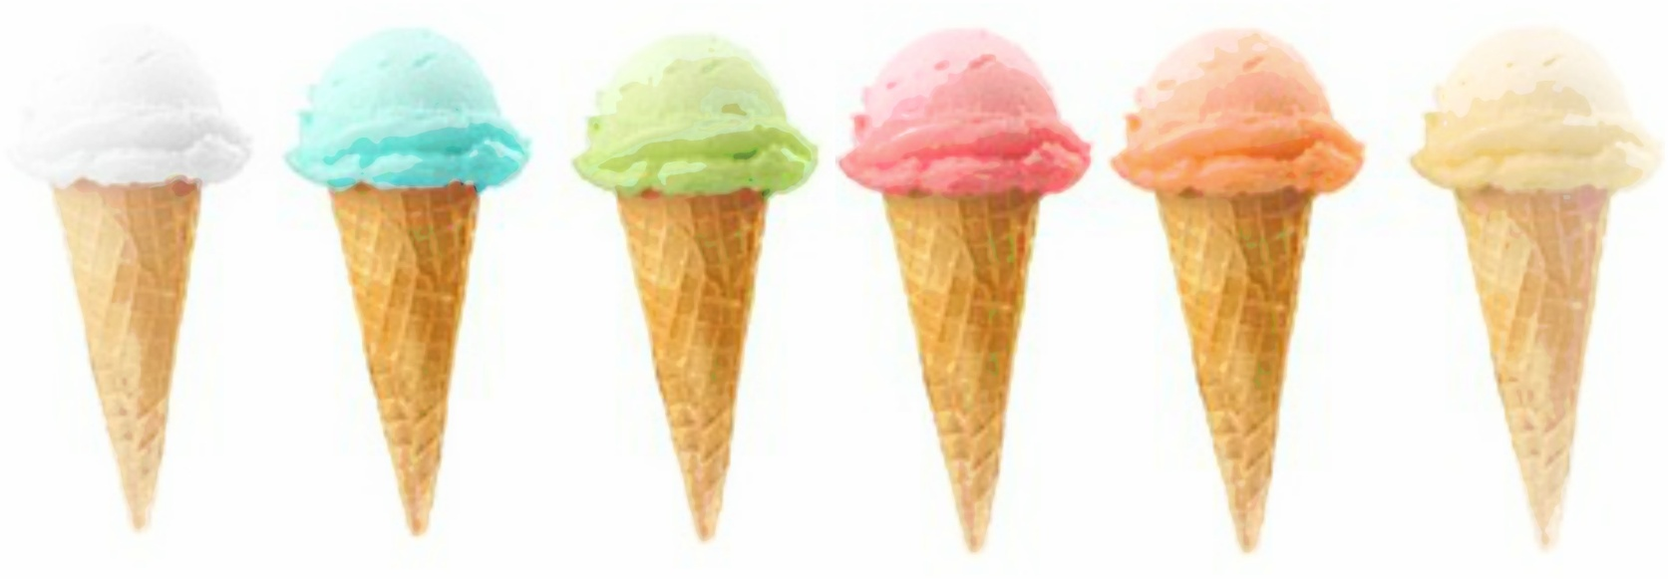

**ICE CREAM, YOU SCREAM!**

**Name:_________________**



Congratulations!

You got the job! Your big task now, is to invent a brand new, delicious flavour for our school ice cream parlour that will be served to all the students here at Kendrick Primary School.

Remember, the flavour that you create must be one that has never been created before. It is your job to find out which new and exciting flavour the students will eat!

Below are 5 places for you to write different flavour of ice cream that you think people might like, or just you!

1. __________________________________________________________

2.__________________________________________________________

3.__________________________________________________________

4.__________________________________________________________

5.__________________________________________________________

6.__________________________________________________________

Ice Cream Flavours Tally

|  |  |  |  |
| --- | --- | --- | --- |
| Flavour | Total | Girls | Boys |
|  |  |  |  |
|  |  |  |  |
|  |  |  |  |
|  |  |  |  |
|  |  |  |  |
|  |  |  |  |

Ice Cream Flavours

Which ice cream flavours would you like to be invented, put the total number of each gender’s choice?

Tick 1 box below:

**Your Choice Girl Boy**

1.___________________

2.___________________

3.___________________

4.___________________

5.___________________

6.___________________

The colour of your ice cream

[](http://www.google.com.au/url?sa=i&rct=j&q=ice+cream+cone+template&source=images&cd=&cad=rja&docid=UQtbvO_Vk_h3mM&tbnid=d2W7Hg9lbK2usM:&ved=0CAUQjRw&url=http://www.craftideas.info/html/ice_cream.html&ei=Roh2UZzRAqauiAekmYGYCQ&psig=AFQjCNHVQkMr0vjs0pVNe4NFf9XvKj8K9A&ust=1366808987049565)Use this ice cream in a cone to show us what colour your ice cream flavour will be

RUBRIC

Year 4 Technology

Date marked: ________________________ Name:____________________________

|  |  |  |  |  |  |
| --- | --- | --- | --- | --- | --- |
| **Assessment Criteria** | **A** | **B** | **C** | **D** | **E** |
|  | **Excellent** | **Good** | **Satisfactory** | **Developing** | **Limited** |
| Ice cream flavours are original | All 5 ice cream flavours recorded are original | 4 ice cream flavours are original and recorded | 3 ice cream flavours are original and recorded | 2 ice cream flavours are original and recorded | 1 or no ice cream flavours are original and recorded |
| Recording data | Records all appropriate quantitative and qualitative data | Records some appropriate quantitative and qualitative data | Records some data | Records minimal data | Records no data |
| Processing data | Processes all data collected with no mistakes | Processes some data collected with no mistakes | Processes minimal data collected with some mistakes | Processes minimal data with multiple mistakes | No processing of data takes place |
| Presenting processed data | Presents all data appropriately and is communicated effectively and accurately | Processes some data appropriately and is communicated effectively and accurately | Processes minimal data in a semi-appropriate manner – this is communicated accurately | Presents minimal data – this is communicated | No presentation of data |